1. **­­­­­­­­HTML Heading , p , br tag:**

<!DOCTYPE html>

<html lang="en">

<head>

<title>Heading-tag in html</title>

</head>

<body>

<!-- Heading Tag-->

<h1>This is h1 heading</h1>

<h2>This is h2 heading</h2>

<h3>This is h3 heading</h3>

<h4>This is h4 heading</h4>

<h5>This is h5 heading</h5>

<h6>This is h6 heading</h6>

<h1>p and br tag</h1>

<p>This is a simple p tag. Lorem ipsum dolor sit amet consectetur adipisicing elit. Voluptate quaerat fugiat reprehenderit. Dolores dolorem, tempore adipisci atque doloremque pariatur possimus. Aliquid corporis voluptatem iste, repudiandae amet, delectus </p>

<p align="right">This is a <b>right</b> aligned p tag. Lorem ipsum dolor sit amet consectetur adipisicing elit. Voluptate quaerat fugiat reprehenderit. Dolores dolorem, tempore adipisci atque doloremque pariatur possimus. Aliquid corporis voluptatem iste </p>

<p align="center"> This is <b>centered</b> aligned p tag. Lorem ipsum dolor sit, amet consectetur adipisicing elit. Dicta quisquam cum asperiores error similique expedita, reprehenderit neque sunt cumque amet illo perspiciatis assumenda rem suscipit. </p>

<p align="justify">This is a <b>justified </b> p tag. Lorem ipsum dolor sit amet consectetur adipisicing elit. Voluptate quaerat fugiat reprehenderit. Dolores dolorem, tempore adipisci atque doloremque pariatur possimus. Aliquid corporis voluptatem iste </p>

<br>

<p>This is line after br tag.</p>

</body>

</html

**Output:**

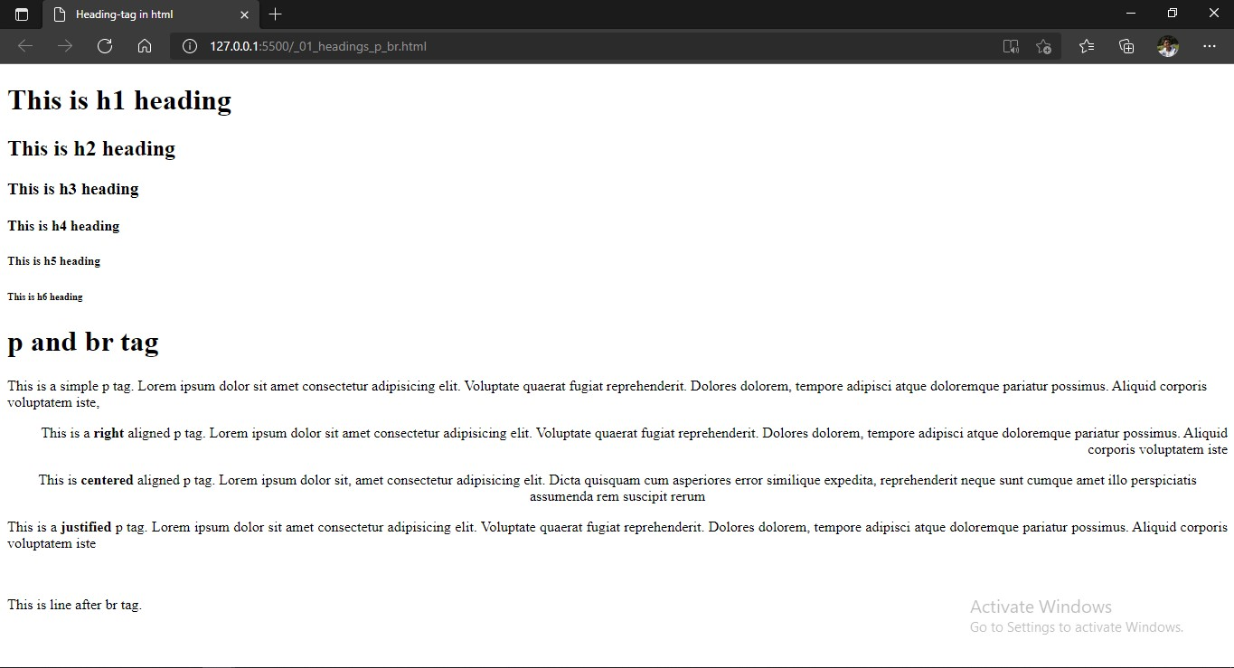

1. **HTML center, div, blockquote, preformatted tag:**

<!DOCTYPE html>

<head>

<title>Centre and Div tag</title>

</head>

<body>

<h1>Centre & Div tag</h1>

<center>

<p>This is a line inside center tag, Center tag is not suported in html5.</p>

</center>

<hr>

 <div align="center">

 <p>These two paragraphs are in div tag aligned="center".</p>

 <p>These two paragraphs are in div tag aligned="center".</p>

 </div>

<h1>Blockquote and Preformatted text</h1>

<p> <h4>Blockquote:-</h4> <blockquote>This is text inside blockquote. Lorem ipsum dolor sit amet, consectetur adipisicing elit. Iste expedita velit saepe ut nostrum maxime sequi in architecto facere, eligendi minima itaque error incidunt corporis quos eveniet ipsam voluptatum voluptatem.</blockquote> </p>

<hr>

<h4>Preformatted tag </h4>

<pre>This    is text inside      preformatted      tag reserving all spaces and tabs.</pre>

</body>

</html>:

**Output:**

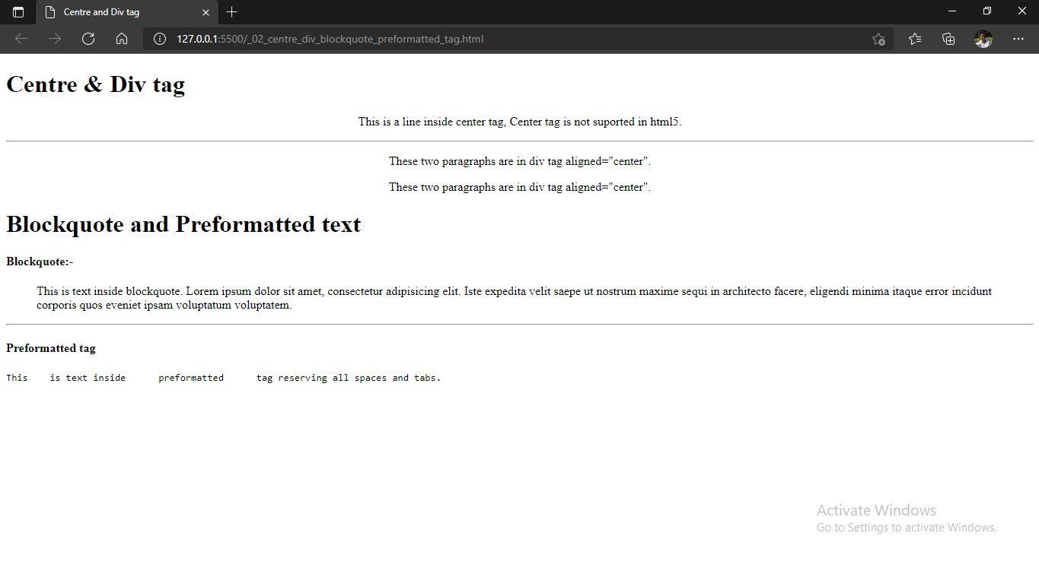

1. **HTML lists:**

<!DOCTYPE html>

<html lang="en">

<head>

<title>lists</title>

</head>

<body>

<h1>lists</h1>

<hr>

<h3>Ordered List:-</h3>

<ol>

<li>item 1</li>

<li>item 2</li>

<li>item 3</li>

</ol>

<p> <u> TYPE="a" START="5" : </u></p>

<ol type="a" start="5">

<li>item=e</li>

<li>item=f</li>

<hr>

<h3>Unordered list:-</h3>

<p><b>Note:</b> by default values allowed:- disc, circle, square</p>

<ul type="square" >

<li>item 1</li>

<li>item 2</li>

<li>item 3</li>

</ul>

<hr>

<h3>Definition List</h3>

<dl>

<dt>Term 1</dt>

<dd>Definition 1. Lorem, ipsum dolor sit amet consectetur adipisicing elit. Fugit, consequatur perferendis voluptatibus itaque expedita dolorem nesciunt vel cum obcaecati adipisci quia animi fuga modi cumque illum consectetur numquam! Sit, accusantium. Et nulla optio sit vitae! </dt>

<dt>Term 2</dt>

<dd>Definition 2> Lorem ipsum dolor sit amet consectetur, adipisicing elit. Exercitationem, qui.</dd>

</dl>

</dl>

</body>

</html>

**Output:**

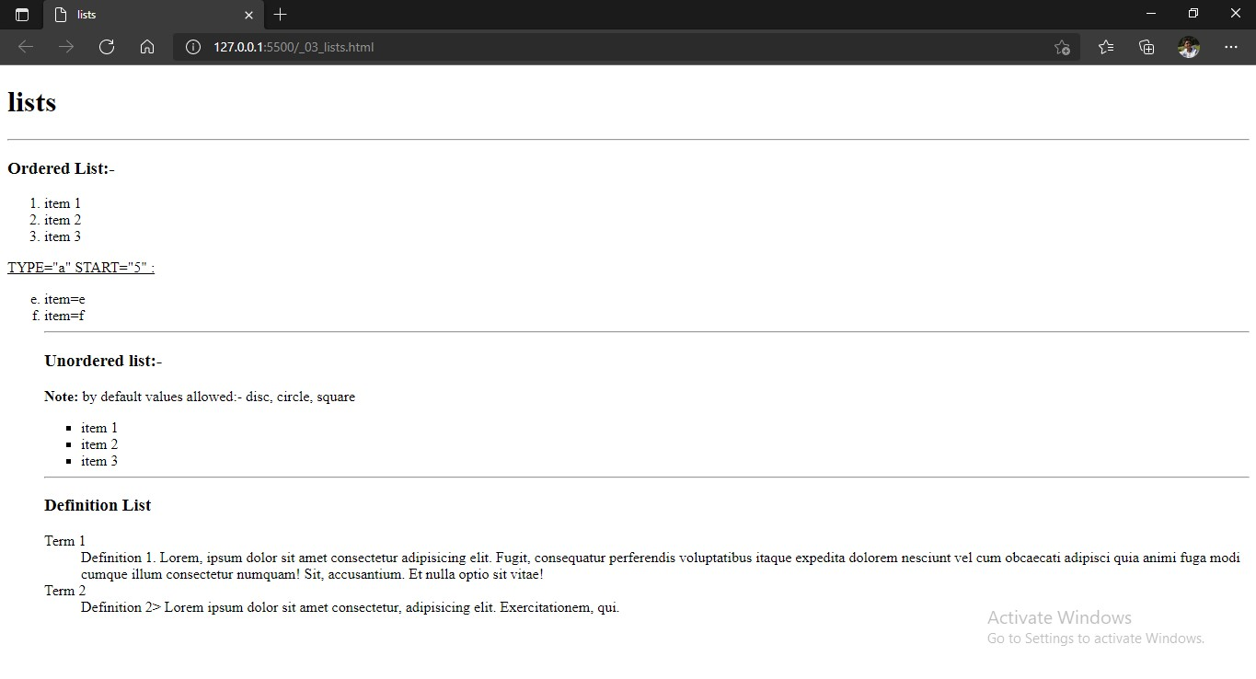

1. **HTML hr, address & text level elements:**

<!DOCTYPE html>

<html lang="en">

<head>

<title>hr & address tag</title>

</head>

<body>

<h1>hr & address tag</h1>

<hr>

<h2>hr tag :</h2>

<pre> Lorem ipsum dolor sit amet consectetur adipisicing elit. Magnam illo dicta atque rerum accusamus voluptatem, sed maiores natus nemo suscipit quos assumenda beatae, enim quasi ab id cum eveniet! Explicabo nam optio ducimus quae. Debitis ea nostrum maiores temporibus facere earum illum similique autem repudiandae quas id dolores, officiis optio!</pre>

<hr size="25"  >

<pre>Lorem, ipsum dolor sit amet consectetur adipisicing elit. Enim omnis tempore, assumenda blanditiis reprehenderit odit. Eius, natus. Magni, nam perferendis!</pre>

<hr size="25" Noshade >

<pre>Lorem, ipsum dolor sit amet consectetur adipisicing elit. Enim omnis tempore, assumenda blanditiis reprehenderit odit. Eius, natus. Magni, nam perferendis!</pre>

<hr size="5" color="red">

<hr size="15" color="red " width="500" align="center">

<br><hr>

<h2>Address tag:</h2>

<Address>

Name: Shubham <br>

E-mail: shubham.sd878@gmail.com <br>

Phone No. 9896813679

</Address>

<hr>

<h2>Text Level Elements: </h2>

<p>This is <b>bold</b>

<i>italic</i>

 tt>monospaced</tt>

 <u>underline</u>

 <strike>strike through</strike>

 <S>strike through</s>

 <big>big</big>

 <small>small</small>

 <sup>superscript</sup>

 <sub>subscript</sub>

<strong>this is strong tag</strong>

</p>

<hr>

</body>

</html>

**Output:**

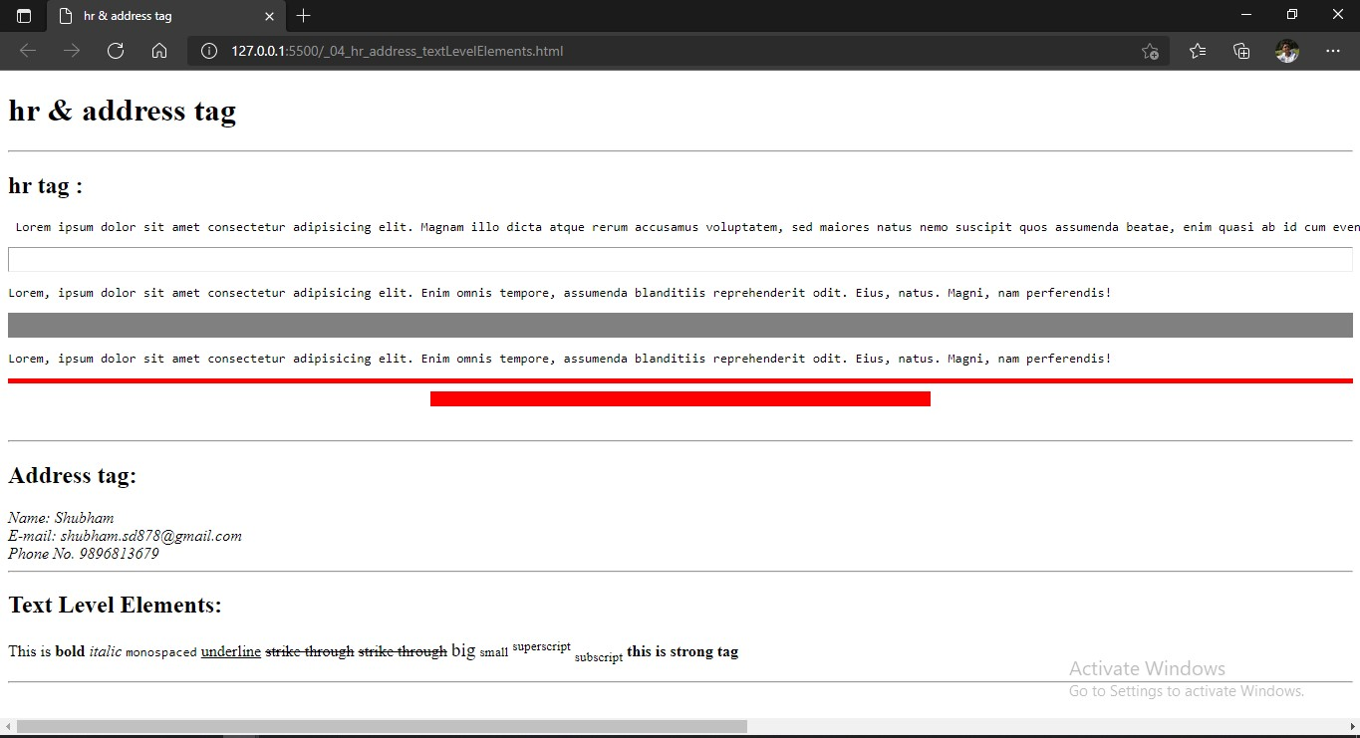

1. **HTML Character Entities, Hyperlinking:**

<!DOCTYPE html>

<html lang="en">

<head>

<title>Hyperlinking</title>

</head>

<body link="green" vlink="brown" alink="red">

<h1>Character Entities:</h1>

<pre> &quot; : Quotation Mark

 &amp; : Ampersand

 &lt; : less-than

 &gt; : greater-than

 &#153; : Trade-Mark

 .&nbsp;&nbsp;&nbsp;&nbsp;. : 4-Spaces

 &copy; : Copyright

</pre>

<h1>Hyperlinking</h1>

<hr>

<pre><b>Note:</b> a tag attributes: title, target.

We also can use <b>link, alink, and vlink</b> attributes in body tag for assigning color</pre>

<a href="_01_headings_p_br.html" title="Click Me!"> Headings in html</a>

<br>

<a href="_02_centre_div_blockquote_preformatted_tag.html" target="_blank">Center Div Blockquote Preformatted tag in HTML</a>

<br>

<a href="_03_lists.html"> lists in HTML</a>

<br>

<a href="_04_hr_address_textLevelElements.html">hr, address, text Level Elements, CharacterEntities in HTML</a>

<hr>

</body>

</html>

**Output:**

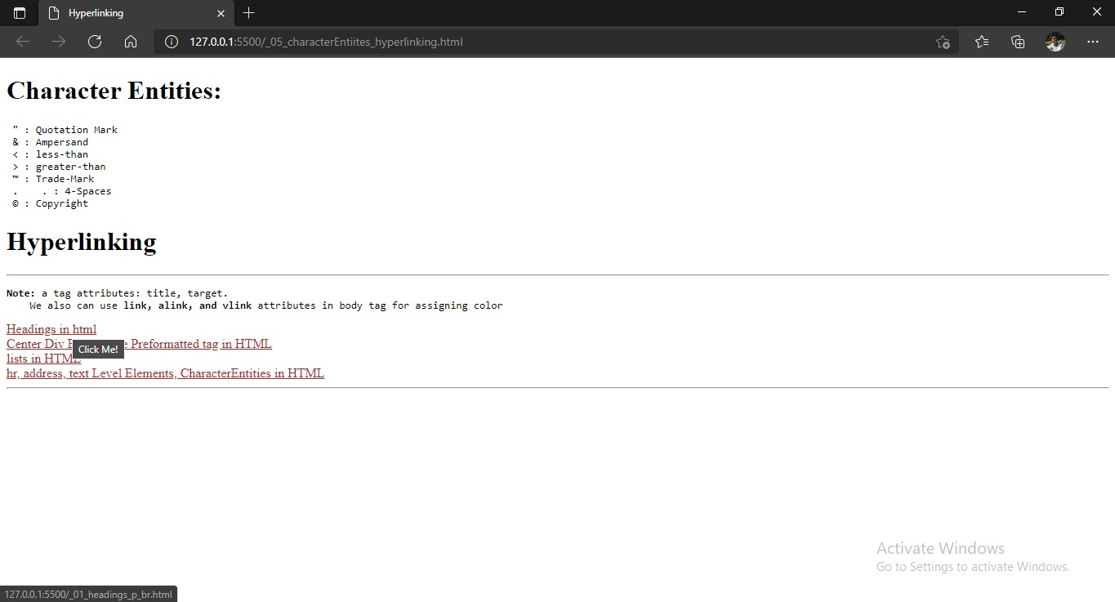

1. **HTML Images:**

<!DOCTYPE html>

<html lang="en">

<head>

<title>Images</title>

</head>

<body>

<h1>Image</h1>

<hr>

<img src="sample_apple.jpg" alt="sample_apple_image" title="Apple Image" height="200">

<h3>Image as link</h3>

<a href="_03_lists.html">

<img src="sample_orange.jpg" alt="sample_orange_image" title="Click to open lists.html " height="300" target="_blank"></a>

</body>

</html>

**Output:**

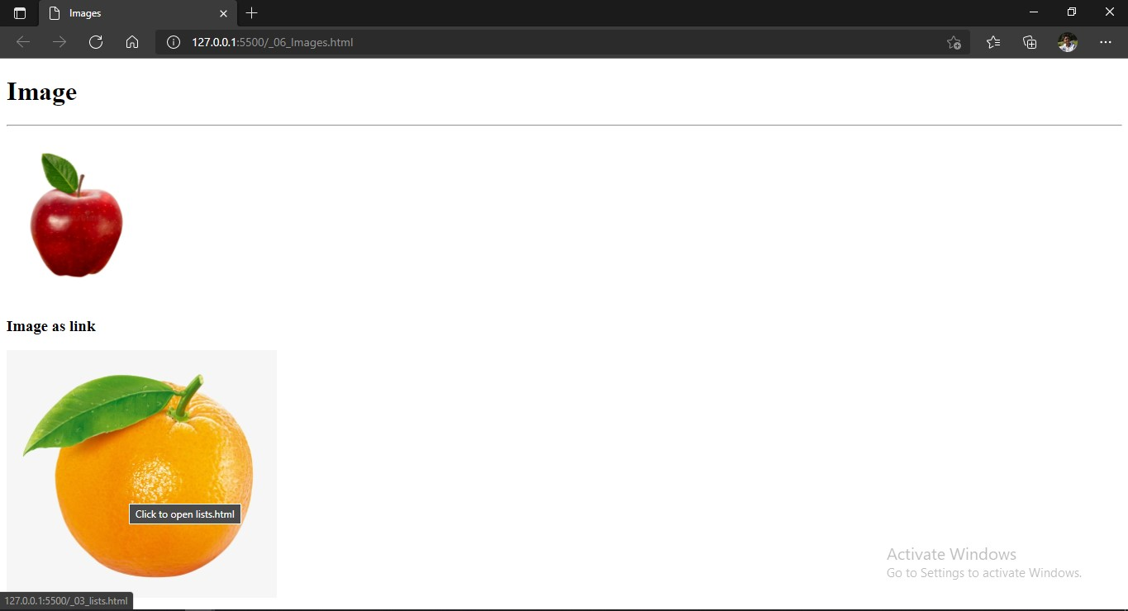

1. **Marquee**

<!DOCTYPE html>

<html lang="en">

<head>

<title>Marquee</title>

</head>

<body>

<h1>Marquee tag</h1>

<marquee behavior="alternate" direction="down" height="100px" bgcolor="#cccccc" onmouseover="stop()" loop="infinite" scrollamount="10" onmouseout="start()">Shubham Dahiya</marquee>

</body>

</html>

**Output:**

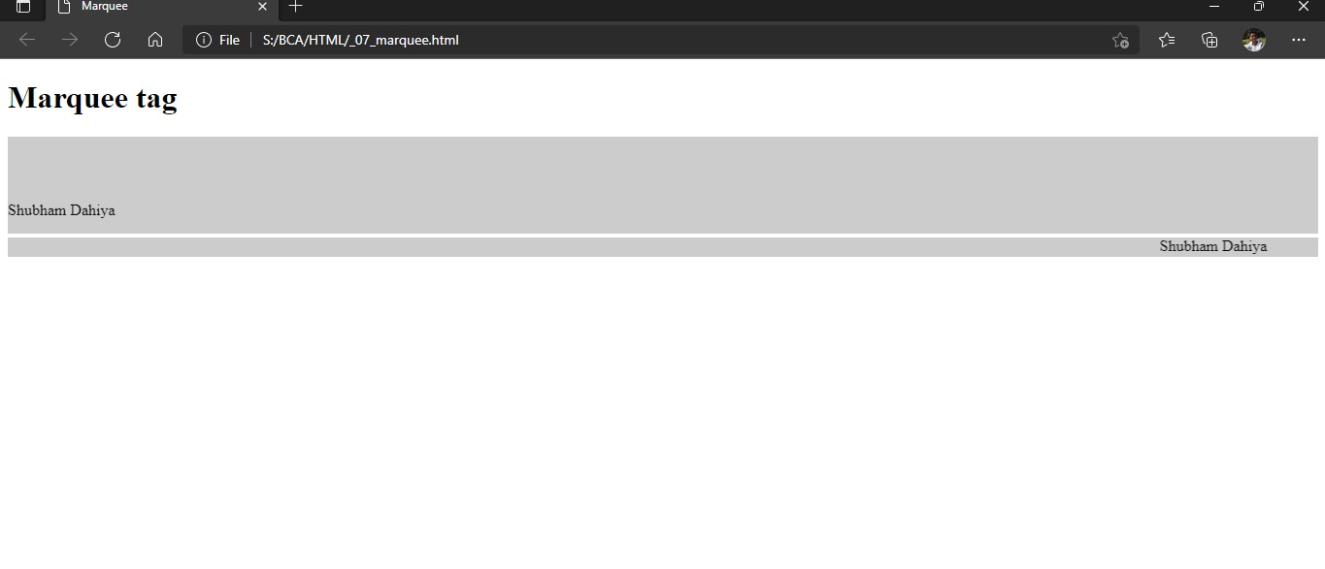

1. **Tables (time-table)**

<!DOCTYPE html>

<html lang="en">

<head>

<title>Tables</title>

<style>

td{text-align: center; }

</style>

</head>

<body>

<center>

<table border="2px" cellspacing="0" cellpadding="20" width="900px" >

<caption>Class Timetable | Shubham Dahiya</caption>

<tr><th ></th> <th >9:30-10:15</th> <th >10:15-11:00</th> <th> 11:00-11:45</th><th >11:45-12:30</th><th >12:30-1:15</th></tr>

<tr><td><b>Monday</b></td> <td>Web Technology</td> <td>OOPs</td> <td>Orgazinational Behaviour</td> <td>Operating System</td> <td>EVS</td></tr>

<tr><td><b>Tuesday</b></td> <td>Orgazitional Behaviour</td> <td> EVS</td> <td>Web Technology</td> <td>OOPs</td> <td>Computer System Architecture </td></tr>

<tr><td><b>Wednesday</b></td> <td colspan="2">OOPs (Lab1)</td> <td>Operating System</td> <td>Web Technology</td> <td>Computer System Architecture</td> </tr>

<tr><td><b>Thursday</b></td> <td colspan="2"> Web Technologies (Lab2)</td> <td>Computer System Architecture</td> <td>Organizational Behaviour</td> <td>Computer System Architecture</td></tr>

<tr><td><b>Friday</b></td> <td>OOPs</td> <td>Computer System Architecture</td> <td>Organizational Behaviour</td> <td>EVS</td> <td>Operating System</td></tr>

</table>

</center>

</body>

</html>

**Output:**

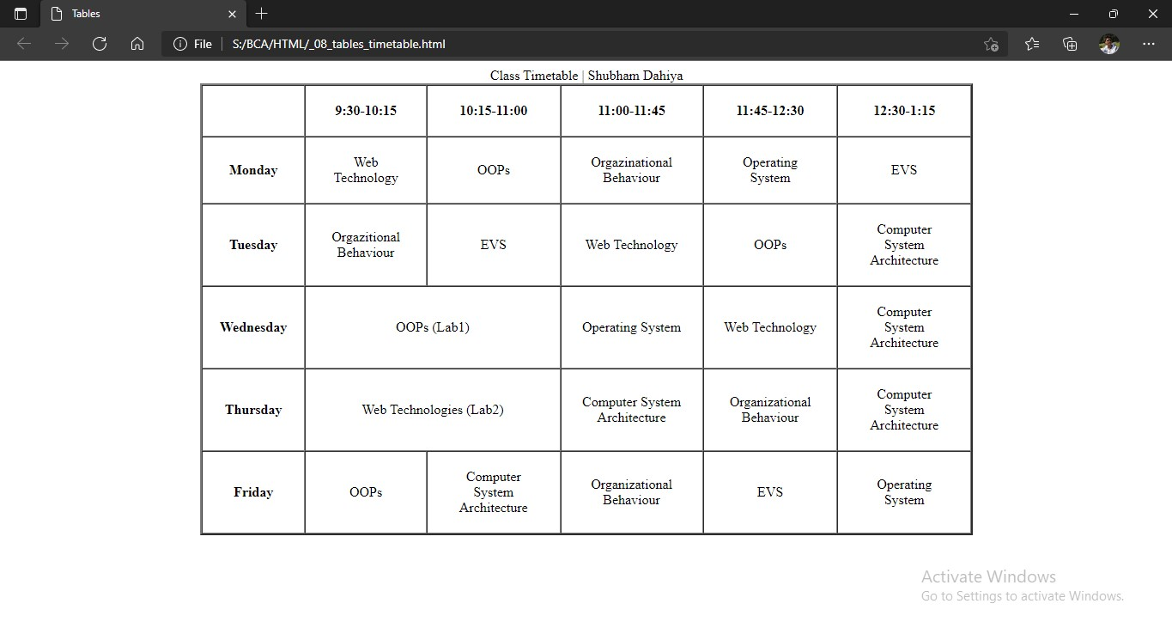

1. **Frames**

<!DOCTYPE html>

<html lang="en">

<head>

<title>Frames</title>

</head>

<frameset cols="*,*">

<frameset rows="*,*">

<frame src="hyperlinking_frames.html">

<frame src="frames_temp.html" name="target2">

</frameset>

<frameset rows="*,*">

<frame src="frames_temp.html" name="target1" />

<frameset cols="*,*">

<frameset rows="*,*">

<frame src="frames_temp.html" name="target3" />

<frame src="frames_temp.html" name="target5" />

</frameset>

<frameset rows="*,*">

<frame src="frames_temp.html" name="target4" />

<frame src="frames_temp.html" name="target6" />

</frameset>

</frameset>

</frameset>

</frameset>

</html>

**Output:**

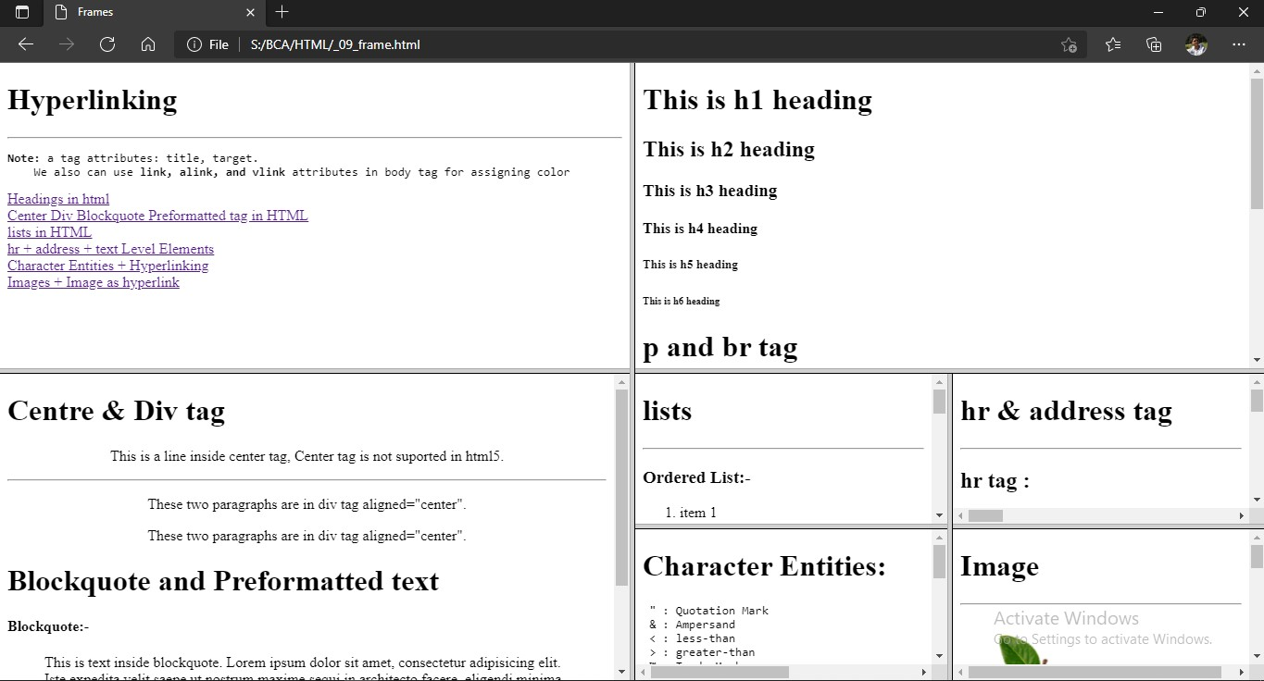

1. **Form type attributes**

<!DOCTYPE html>

<html lang="en">

<head>

<title>HTML Form</title>

</head>

<body>

<h1 face="">HTML Forms attribute type:</h1>

<hr>

<form action="" target="" method="">

<!-- 3 attribute: action, target, method, autocomplete="on/off", novalidate (empty attribute) -->

<label for="">radio:  </label>

<!-- action attribute takes to the path to the backend page-->

<input type="radio" name="number">

<!-- type : by-default = text  -->

<!-- name : without name the value will not be submited to action page.

must have, without it we can select mulitple options-->

<!-- for : has same value as of input "id" -->

<label >One</label>

<!-- label tag have the value to show to the user of the website -->

<input type="radio" name="number">

<label for=""> Two </label>

</form>

<hr>

<form action="">

<label for="">checkbox:  </label>

<input type="checkbox" id="id1" name="check1">

<label for= "id1">option_1</label>

<input type="checkbox" id="id2" name="check1">

<label for="id2" name="check1">option_2</label>

</form>

<hr>

<form action="">

<label for="">text:  </label>

<label for="fname">First Name:</label>

<!-- label : before input in this type of case -->

<input type="text" id="fname" name="fname">

<label for="lname">Last Name: </label>

<input type="text" id="lname" name="lname">

</form>

<hr>

<!-- *** type="hidden" Understand it *** -->

<form action=" ">

<label for="" >hidden: </label>

<input type="hidden">

</form>

<!-- *** type="image" How to use it *** -->

<hr>

<form action="">

<label for="">image: </label>

<p>Image is used to submit</p>

<input type="image" src="img_submit.gif" height="48" width="48">

</form>

<!-- ***type="range" How to use it*** -->

<hr>

<form action="">

<label>range: </label>

<input type="range">

</form>

<!-- ***type="reset" How to use it*** -->

<hr>

<form action="">

type value to reset:

<input type="text">

<label>reset: </label>

<input type="reset">

</form>

<!-- ***type="search" How to use it*** -->

<hr>

<form action="">

<label>search: </label>

<input type="search">

</form>

<hr>

<!-- ***type="tel" Why to use tel*** -->

<form action="">

<label>tel: </label>

<input type="tel">

</form>

<hr>

<form action="">

<label for="">color:</label>

<input type="color">

</form>

<hr>

<form>

<label for="">button: </label>

<input type="button" value="Button" onclick="alert('Hello! World')">

</form>

<hr>

<form action="">

<label>date: </label>

<input type="date">

</form>

<hr>

<hr>

<form action="">

<label>datetime:</label>

<input type="datetime">

</form>

<hr>

<form action="">

<label>datetime-local</label>

<input type="datetime-local">

</form>

<hr>

<form action="">

<label>month: </label>

<input type="month">

</form>

<hr>

<form action="">

<label>time: </label>

<input type="time">

</form>

<hr>

<form action="">

<label>week: </label>

<input type="week">

</form>

<hr>

<form action="">

<label for="">email:</label>

<input type="email">

<input type="submit">

</form>

<hr>

<form action="">

<label for="">file:</label>

<input type="file">

</form>

<hr>

<form action="">

<label for="">multiple file:</label>

<input type="file" multiple>

</form>

<hr>

<form action="">

<label>number: </label>

<input type="number">

</form>

<hr>

<form action="">

<label>password: </label>

<input type="password">

</form>

<hr>

<form action="">

<label>submit: </label>

<input type="submit">

</form>

<hr>

<form action="">

<label>url: </label>

<input type="url">

</form>

</body>

</html>

**Output:**

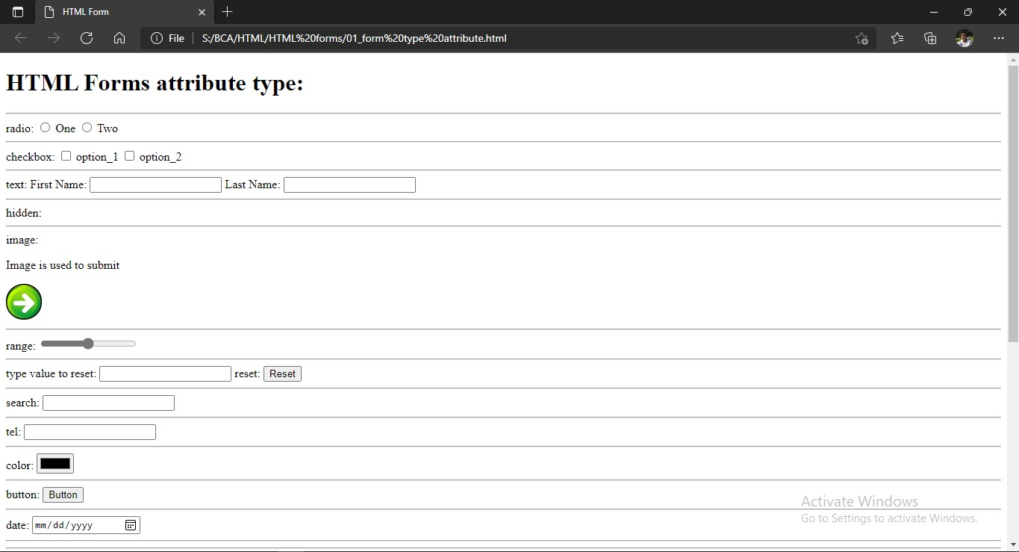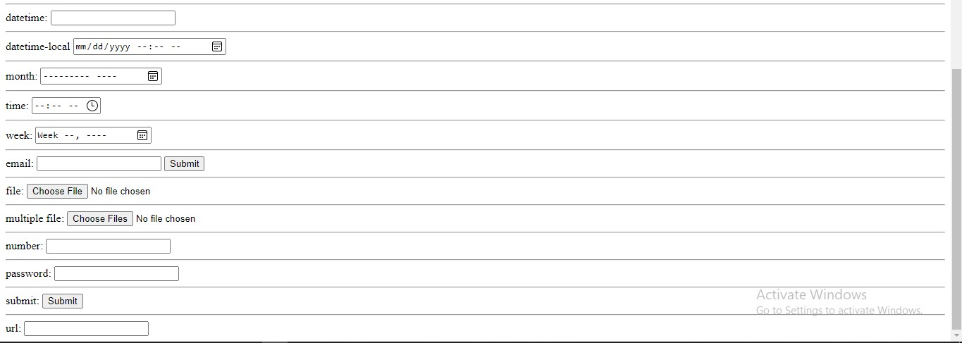

1. **Form Elements**

<!DOCTYPE html>

<html lang="en">

<head>

<title>Form elements</title>

</head>

<body>

<h1>Form elements</h1>

<label for="">#8 output: </label>

<br>

<br>

<br>

<form >

<!-- #1 label -->

<label for="">#1 label (This is a label)</label>

<br>

<br>

<label for=""> #2 input:       </label>

<input type="submit" value="sbmit">

<br>

<br>

<label for="">#3 select: </label>

<select name="option" id="" size="4" multiple>

<!-- size : no. of visible values  -->

<!-- multiple : user can select multiple values -->

<option value="option1">option1</option>

<option value="option2">option2</option>

<option value="option3">option3</option>

<option value="option4">option4</option>

<option value="option5" selected>option5</option>

<!-- selected : by default this option will be selected -->

<option value="option6">option6</option>

<option value="option7">option7</option>

<option value="option8">option8</option>

</select>

<br>

<br>

<br>

<label for="">#4 textarea:   </label>

<textarea name="textarea000" id="" cols="30" rows="10" >              </textarea>>

<!-- can also define area with the help of CSS by using width-height -->

<br>

<br>

<br>

<label for="">#5 fieldset(group related data in a form) + #6 legend(a caption for fieldsets) :</label>

<br>

<br>

<fieldset>

<br>

<legend>#6_Lengend of #5_fieldset</legend>

<label for="fname">First Name: </label>

<input type="text" id="fname" value="Shubham" name="fname">

<br>

<br>

<label for="lname">Last Name: </label>

<input type="text" id="lname" value="Dahiya" name="lname">

<br>

<br>

<input type="submit" value="submit" >

<input type="reset" value="clear">

</fieldset>

<br>

<br>

<br>

<label for="">#7 datalist: </label>

<input list="abc" >

<!-- list : have same value as of "id" in datalist.  -->

<datalist id="abc">

<option value="abc1">

<!-- opiton : doesn't have end tag -->

<option value="abc2" >

<option value="abc3">

<option value="abc4">

<option value="abc5">

<option value="abc6">

</datalist>

</form>

</body>

</html>

**Output:**

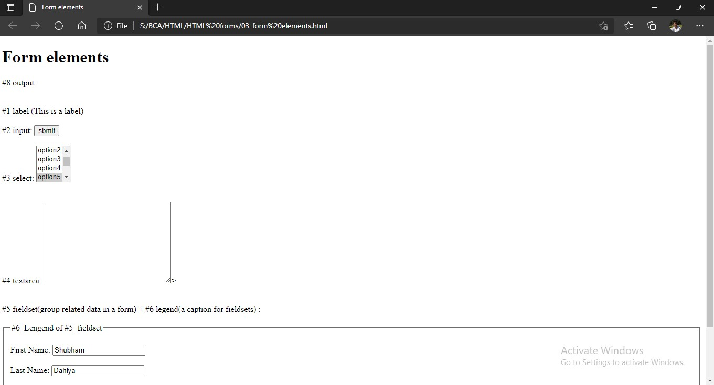

1. **Form Input Attributes**

<!DOCTYPE html>

<html lang="en">

<head>

 <title>Input Attribute </title>

</head>

<body>

<h1>Input Attributes</h1>

<hr>

<form action="">

<h3>#1 value + #2 readonly: </h3>

<label for="fname1">First Name</label>

<input type="text" id="fname1" value="predefined" readonly>

<hr>

<h3>#3 disabled</h3>

<label for="fname2">First Name</label>

<input type="text" id="fname2" value="predefined" disabled>

<hr>

<h3>#4 size</h3>

<p><b>Note: </b> Size & Maxlength is only going to work in: <u> text, search, tel, url, email, and password </u></p>

<br>

<br>

<label for="pin1"> Pin:</label>

<input type="text" id="pin1" title="Enter Pin here" size="5">

<!-- Size is only going to work in: text, search, tel, url, email, and password -->

<br>

<br>

<label for="pin2"> Pin:</label>

<input type="number" id="pin2" value="014" size="5">

<br>

<hr>

<h3>#5 maxlength</h3>

<label for="pin3">Pin: </label>

<input type="number" id="pin" name="pin" maxlength="4" size="4">      <!-- maslength not working-->

<input type="text" id="pin2" value="0123" maxlength="5" size="4">

<hr>

<fieldset>

<legend> <h3> #6 max + #7 min </h3></legend>

<!-- <h3>#6 max + #7 min</h3> -->

<h5>date syntax = "YYYY-MM-DD"</h5>

<label for="datemax">Enter a Date between 2021-10-01 to 2021-10-31:</label>

<input type="date" id="datemax" min= "2021-10-01" max="2021-10-31">

<!-- date syntax = "YYYY-MM-DD" -->

</fieldset>

<br>

<hr>

<h3>#9 multiple</h3>

<p> &nbsp &nbsp &nbsp &nbspi.e. user can enter more than one values</p>

<label for="file">Select file</label>

<input type="file" id="file" multiple>

<br>

<hr>

<h3>#10 Pattern</h3>

<p><b>to be done after JS_Regular_Expressions</b></p>

<br><br>

<hr>

<h3>#11 placeholder</h3>

<label for="phone">Phone No. :</label>

<input type="tel" id="phone" name="phoneNumber" placeholder="0123-456-789" maxlength="10">

<br>

<hr>

<h3>#12 required</h3>

<p><B>Note:</B> Supported types: text, search, url, tel, email, password, date pickers, number, checkbox, radio, and file.

Example</p>

<label for="rollno.">Roll No. :</label>

<input type="text" id="rollno." name="rollno." required>

<input type="submit" name="submit">

<br>

<hr>

<h3>#13 step</h3>

<p>step attribute specifies the legal number intervals for an input field. </p>

<p> <b> Example: </b> if step="3", legal numbers could be -3, 0, 3, 6, etc. </p>

<p> <b> Tip:b </b> This attribute can be used together with the max and min attributes to create a range of legal values. </p>

<p>   The step attribute works with the following input types: number, range, date, datetime-local, month, time and week.</p>

<label for="step">Points:</label>

<input type="number" id="step" step="3" required >

<input type="submit" name="submit">

<br>

<hr>

<h3>#14 autofocus</h3>

<label for="fname2"> First Name:</label>

<input type="text" id="fname2" name="fname2" autofocus>

<label for="lname2"> Last Name:</label>

<input type="text" id="lname2" name="fname2" autofocus>

<br>

<hr>

<h3>#15 height width</h3>

<p><b>type="submit"</b> work as if submit</p>

<input type="image" src="img_submit.gif" height="48" width="48">

<br><hr>

<h3>#16 list</h3>

<p><b>Note:</b> list=" id(datalist) " has the same value as id of datalist element</p>

<input list="browsers">

<datalist id="browsers">

<option value="Internet Explorer">

<option value="Firefox">

<option value="Chrome">

<option value="Opera">

<option value="Safari">

</datalist>

<br><hr>

<h3>#16 autocomplete = "on/off"</h3>

<fieldset>

<legend>Autocomplete:<b> //NOT Working</b> </legend>

<label for="fname" autocomplete="off">First name:</label>

<input type="text" id="fname" name="fname" autocomplete="on"><br><br>

<label for="lname" autocomplete="on">Last name:</label>

<input type="text" id="lname" name="lname" autocomplete="on"><br><br>

<label for="email" autocomplete="on">Email:</label>

<input type="email" id="email" name="email" autocomplete="off" ><br><br>

<input type="submit" value="Submit">

</fieldset>

</form>

</body>

</html>

**Output:** 